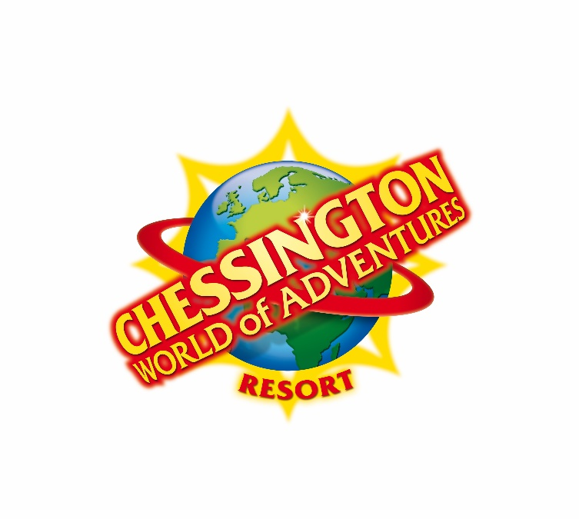

Risk Assessment Form: Chessington World of Adventures Resort

About Chessington World of Adventures Resort
Chessington World of Adventures Resort is an ideal venue for out-of-classroom learning. With experiences developed specifically for the
visual, auditory and kinaesthetic model, a trip to Chessington World of Adventures Resort appeals to all students, no matter what their style
of learning.
A school visit to Chessington World of Adventures Resort helps to bring classroom learning to life. While the rides and exhibits are
appealing in themselves, they become even more intriguing when viewed as practical, real world applications of abstract academic
concepts.

About Merlin
Merlin Entertainments Group is the leading name in location based, quality family entertainment. Now the world's number two visitor
attraction operator, it aims to deliver unique, memorable and rewarding experiences to its 30 million visitors worldwide, through its iconic
global and local brands, and the commitment and passion of its managers and employees. Merlin has over 50 attractions, in 12 countries,
across three continents - Europe, North America and Asia - and employs over 13,000 staff.

Legal Requirements and Attraction Information
Public Liability | Chessington World of Adventures Resort is covered by Public Liability Insurance to the amount of £10 million. The Policy is with Chubb European Group Limited (Policy No UKCANC33447).
Local Enforcement Agency | Royal Borough of Kingston.
Rides Engineering / Maintenance | Fairground and Amusement Parks – Guidance on Safe Practices HSG 175. The zoo is operated under strict licensing conditions as established within the Zoo Licensing Act 1981.
Food Safety and Hygiene | All food outlets operate in accordance with the Food Safety Act 1990. They are regularly inspected by the local Environmental Health Department.
Attraction Staff / Staff identification | All staff members wear uniforms and name badges for easy identification.
Security | The attraction has a dedicated security team who are able to deal with security issues on site.  The team is also trained to deal with emergency incidents that may arise.

Risk Assessment
Vehicle traffic | The Park is closed to vehicular traffic movement whilst open to the public. There are designated drop-off points for coaches at Chessington World of Adventures Resort. There is no requirement  for children to cross any busy public roads although children will be required to cross-internal  Park roads to access the admissions area. Pedestrian walkways are provided where possible.
Weather protection / Sun safety | Please dress for the changeable British weather. There is not a great deal of cover around the  Park, please be prepared for rain at all times and wear sensible flat footwear due to the undulation of the Park and the need to brace on several of our rides. There are shaded areas provided throughout the attraction for sunny weather.
Water | The following rides and play areas expose children to water: Gruffalo River Ride Adventures, Dragon Falls, Monkey Swinger, Rameses Revenge, Sea Dragons, Sir Squirt allot and Squirting Elephants & tree. There are ponds at the Resort located near in Land of the Dragons, Wanyama Village, Land of the Tiger, and at the back of the hotel.
Slips/ Trips/ Falls | The following hazards should be noted:  􀀹 Wet flooring / Wet weather  􀀹 Steps and stairs  􀀹 Care must be taken when boarding and disembarking rides
High level areas | Handrails are provided where necessary. There are no steep slopes at the Resort. Due to the  nature of the Resort being situated on slight hills, scooters, roller skates and children's tricycles  are not permitted into the Resort. For their own safety we request that children wearing Wheel  Heeled shoes (Heeleys) do not activate the wheel part of the shoe and take due care and  attention whilst in the Resort.
Strobe lighting | A few attractions feature strobe lighting. This information can be found on the signage boards at the entrance to each ride.
Reduced Lighting | A few attractions feature reduced lighting. This information can be found on the signage at the entrance to each ride.
Enclosed spaces | Some of the rides and attractions can be quite small in area and to some individuals these may feel confined. However no areas on the Resort can be defined as a confined space.
Attraction specific risk | Rides  All rides are inspected daily by our team of engineers and undergo annual inspection and certification by an independent inspection body.  Zoo  All animal enclosures are inspected daily by our Zoo Keepers. All animals undergo regular health  checks with new animals being put through strict quarantine procedures. Guests can only come  into contact with very low risk friendly animals in the Children’s Zoo and the SEA LIFE centre.  This area is manned by a member of the Zoo team to ensure the guest safety and there are  hand washing facilities as well as anti-bacterial hand wash.
Door entrapment | Beware of closing doors / ride security equipment on fingers etc.
Rides | All rides safety instructions must be obeyed. Rides undergo rigorous testing every day by competent engineers in accordance with manufacture guidelines.
Soft play areas / Play equipment | All the soft play areas on the Resort go through the same inspection procedures as any ride at Chessington World of Adventures Resort. All soft play areas are designed, installed and maintained according to BSEN1176 & BSEN 1177.

Attraction Arrangements
Arrival arrangements | The drop off / pick up point is situated at the main entrance (Lodge Gate) to the Resort. Maps are  available to adults and teachers who are supervising the school trip. School parties are fast  tracked through admissions entry.
Parking | There is ample car / coach parking facilities available.
First aid | There is a First Aid Centre permanently staffed by fully qualified first aiders. Location is clearly  marked on the Resort map.
Emergency planning | Chessington World of Adventures Resort has contingency plans in the event of an emergency.  The emergency plans have been developed in conjunction with the local emergency services  who have regular meetings and training exercises regarding emergency procedures.
Fire safety | In the event of an emergency please follow all evacuation procedures as instructed by the staff.
Wheelchair access | The large majority of our rides and attractions are accessible for wheelchair users.  Guests with disabilities who are unable to use the normal queue lines, may visit Guest Help and Information (located in Adventure Point) where they may be able to receive preferential ride access wristbands (documentary proof of disability may be required).These wristbands allow preferential access to the rides via entry points designed for ease of access.
Lost children | Lost children should report to a member of staff. The lost person centre is located in the First Aid  Centre (located by Rameses Revenge)
Unruly children | The Resort has regulations displayed at the entrance. Staff members are trained to enforce these regulations for the benefit of all guests. Staff will instruct children to behave where necessary.
Age / height restrictions | There are height restrictions on some of the rides at the Resort. Specific restrictions can be  found on the Resort maps, which are given out on the day of your visit or available to download  on the Chessington website www.chessington.com or using the Chessington World of Adventures app which can be downloaded for free from most app providers. Please read the ride restrictions situated at  the entrance to each ride prior to entering the queue line.
Lockers / storage facilities | Lockers are available in Adventure Point, Wild Woods and at Land of the Dragons and are clearly  marked on the Resort map.
Eating facilities | There are several food and drink establishments within the Resort serving a variety of hot and  cold meals / drinks and healthy eating options are available. There are also adequate picnicking  facilities within the grounds. Allergy information can be found in all of our eating establishments please speak to a member of the catering team before placing an order
Welfare facilities | Toilets are located at various locations in the Resort. These are clearly sign-posted on maps and  sign-posted within the Resort. An individual disabled toilet is located at all these locations. Baby  change facilities are located at Lodge Gate, Adventure Point, Land of the Dragons, Forbidden  Kingdom and Wild Woods.
Additional costs  . | There are several outlets around the Resort serving snacks and drinks. There are also vending  machines available on site
Attraction signposting | The Resort is well sign-posted. Also, Resort maps are issued to all adults and teachers who are  supervising the school trip. In order to avoid queuing or to pre-print additional maps in advance,  please visit www.chessington.com.
Smoking  COVID19 | Chessington World of Adventures Resort respects that the majority of our adventurers are  families. Smoking is now only permitted at designated areas throughout the park. These are  highlighted on the park map.  The resort is providing several methods of reducing the likelihood of transmission between people, and our animals.  We are following all Government guidelines with regards to the assessment and subsequent reopening of areas, attractions and rides within the Resort.  Control measures currently in place are (but not limited to), reduced capacity within the theme park, rides and Leisure club; temperature checking of all guests, employees and contractors upon entry; easily accessible hand sanitiser at ride entry points and increased cleaning of all common touch points (including rides). Face masks are also mandatory when riding a selection of rides as well as in all indoor/covered spaces (in line with Government advise) and we are operating of a pre-book basis to both manage capacity as well as to ensure a track-and-trace system is in place for all our visitors.

